Match definition and word:
Ion | Alkali Metals | Atomic radius | Taxonomy | Octet rule
- Atoms want to have either 8 or 0 electerons in their outermost shell.
- The first group in the periodic table
- Trend on the period table in which Fr is the high end and He is the low end.
- Study of relatedness and trends in biology
- Atoms with a differing number of electrons

- Water is a covalent bond, every water we see on the earth is made up of tiny little atoms.
  - Draw the lewis structure of water.

  - Discuss whether water is polar or not, the electronegativity of H is 2.20 and that of O is 3.55.
______________________________________________________________________________________________________________________________________________________________________________________________________________________________________________________________________________________________________________________________________________________________
- Life needs to be organized, taxonomy is how we do that!
  - Fill in the missing parts of the taxonomic tree
Kingdom – P______ - Class – O_______ - F________ - Genus – S_________
  - Describe in which part of the taxonomy would animals be more related, in a genus or a kingdom.
______________________________________________________________________________________________________________________________________________________________________________________________________________________________________________________________________________________________________________________________________________________________
  - What would be the scientific name of the species in the following family, genus and species: wasin, dreepi, plopr
______________________________________________________________________
- Magnesium and oxygen form a particular bond.
  - Explain which bond this is, and how you know.
______________________________________________________________________________________________________________________________________________________________________________________________________________________________________________________________________________________________________________________________________________________________
  - Draw the dot and cross diagram of magnesium and oxygen, and draw arrows indicating the transfer of electrons.

  - now draw the shell diagrams of each ion after this electron transferal.

- Naming of elements can be tough sometimes. Luckily for you we can practice
  - Name the following ionic compounds: NaCl, Fe(II)O, Mg₃N₂

  - Name the following covalent compounds: CO₄, N₃F₂, CH₄

  - Name the two forms of metallic bonds.
____________________________________________________________________________________________________________________________________________
- Sometimes (jk a lot of times) atoms meet and react to form compounds in a chemical equation. One of those is the formation of Chromium (III) Sulfide.
  - What type of compound is this?
____________________________________________________________________________________________________________________________________________
  - State the charge of the chromium.

  - Balance the reaction for the formation of Chromium (III) Sulfide:
Cr + S₈ → Cr₂O₃

- Certain bonding types have different properties. Below are some questions in which you elaborate on these properties.
  - Explain why ionic compounds cannot conduct electricity when solid, but are able to do so when dissolved or molten.
__________________________________________________________________________________________________________________________________________________________________________________________________________________

  - Covalent bonds often have lower melting points than ionic compounds. Explain why this is.
________________________________________________________________________________________________________________________________________________________________________________________________________________________________________________________________________________________
  - Metallic bonds are shiny and can conduct electricity. Explain how these two properties arise in metallic bonds.
______________________________________________________________________________________________________________________________________________________________________________________________________________________________________________________________________________________________________________________________________________________________
- Draw the lewis structure of the following compounds:
  - NH₃
  - CO₂
  - C₃H₁₀
- Forces are AMAZING and can describe two things of the movement of an object:
  - Name these two things: (Aka state what two things a force depicts)
__________________
__________________
  - Draw the forces acting on the box in the story below:
On earth, there is a box on wheels accelerating towards the right on a straight road.
  - Calculate the net force in figure below.
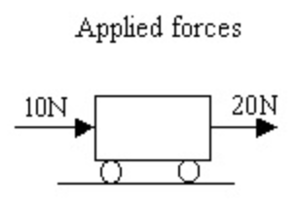
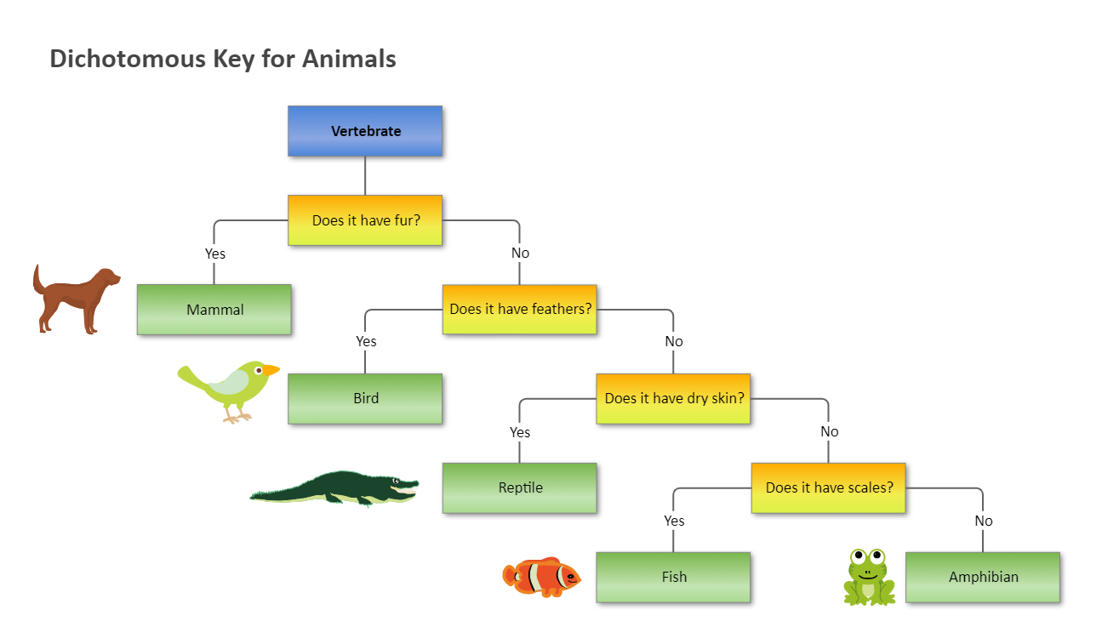
- Dichotomous keys
  - Explain as what the animal to the right could be classified as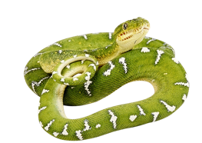
________________________________________________________________________________________________________________________________________________________________________________________________________________________________________________________________________________________

  - Explain how useful the dichotomous key above is in the following examples is:
    - Jimbo lost his pet puffer fish in a heavy rainfall when he was taking it out on a walk. There are a lot of different pufferfish in this city, and Alex hopes that the dichotomous keys above can help the people in the city find his pufferfish.
__________________________________________________________________________________________________________________________________________________________________________________________________________________________________________________________________________________________________________________________________________________________________________________________________________________________________________________________________________________________________________
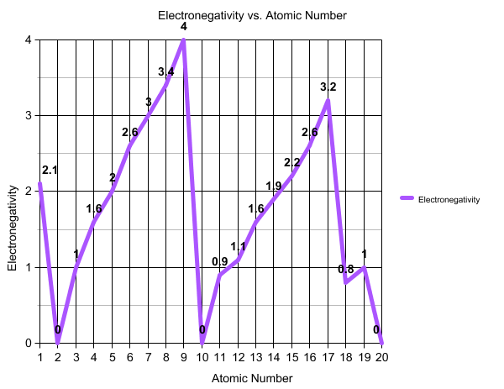
- Graph exercise the graph to the right shows the trend of electronegativity and the different atomic numbers.
  - Describe the trend of electronegativity going down a period.
__________________________________________________________________________________________________________________________________________________________________________________________________________________________________________________________________________________________________________________________________________________________________________________________________________________________________________________________________________________________________________
Explain the dips and peaks in the graph.
__________________________________________________________________________________________________________________________________________________________________________________________________________________________________________________________________________________________________________________________________________________________________________________________________________________________________________________________________________________________________________

